Q1. WAQ to display the details of all countries.

select* from countries;

select country_name from countries ;

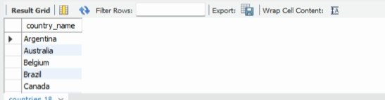  
Q2. WAQ to display the employee number,name,phonenumber of those employees who are in department 8.

select employee_id,first_name,phone_number from employees where department_id=8;

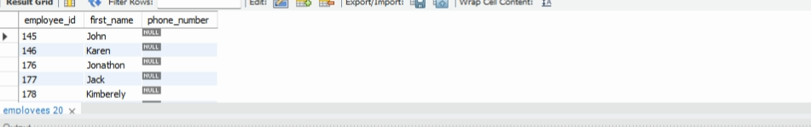  
Q3. WAQ to display details of those employees who were hired in the year 2000.

SELECT first_name, last_name, hire_date from employees where year(hire_date) like '2000-01-01';

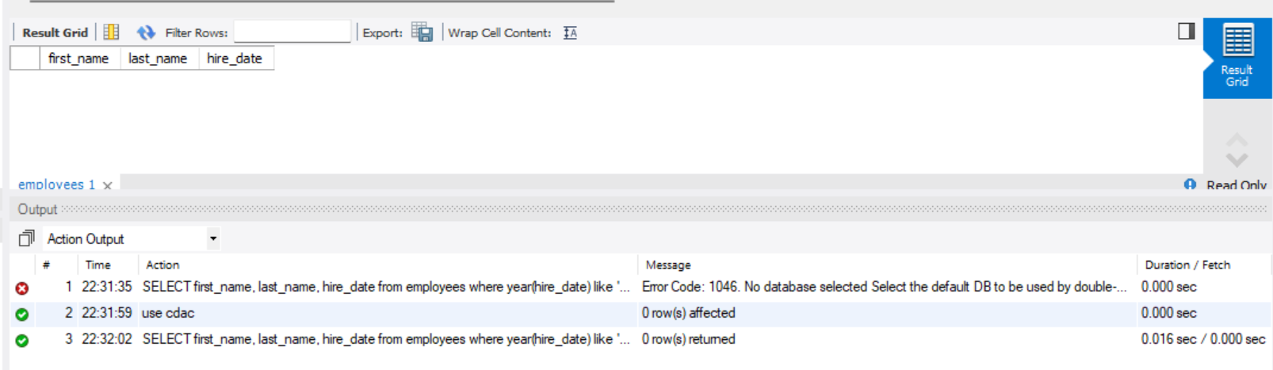

Q4. WAQ to display details of those employees who jobid is 10 and salaries are less than 10000.

SELECT last_name, job_id, salary from employees WHERE job_id IN ('10') and salary <=10000;

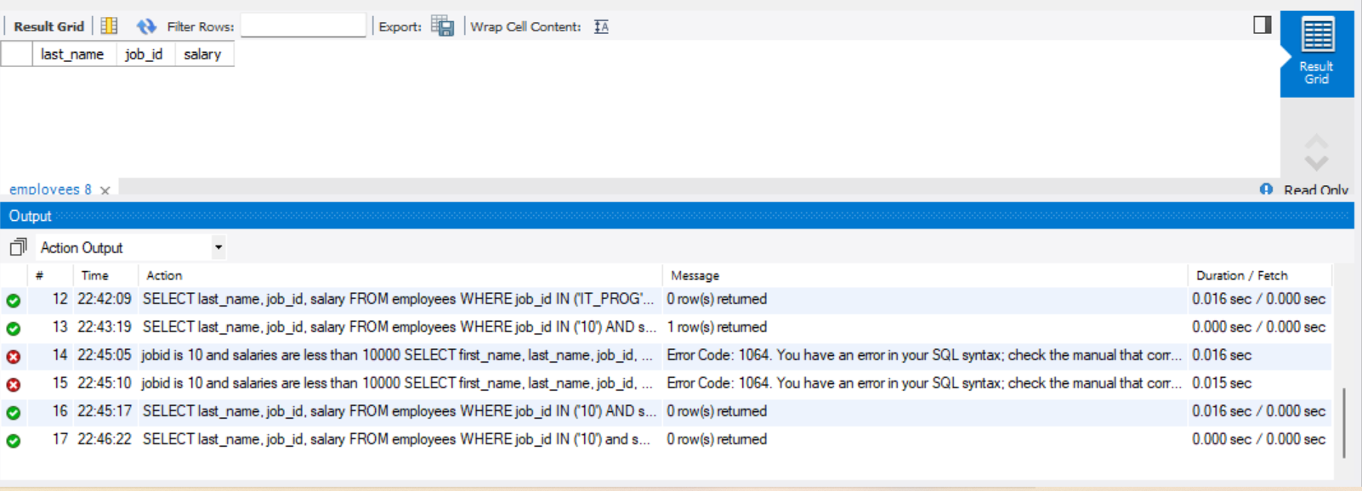

Q5. WAQ to display the details of those employees either department is 6 or the hiredate is in year 1999.

WAQ to display the details of those employees either department is 6 or the hiredate is in year 1999.

